Year 5 Autumn 2 | Key Dates
Year 5 Autumn 2  What makes the Polar regions unique?  This term, children will read Race to the Frozen North by Catherine Johnson, learning about explorer Matthew Henson. They will write a biography of his life and a discussion text exploring the pros and cons of ecotourism, developing research, reasoning and persuasive writing skills.  Throughout this topic, the children will develop their geography skills by looking at the expeditions of famous explorers. | First day of term: 03.11.25  Flu immunisations – 05.11.25  Odd Socks Day – 10.11.25  Trip to Sea Life - 18.11.25  Christmas Jumper & Dinner Day – 11.12.25  WBP Winter Wonderland – 11.12.25  Autumn Term Reports – 15.12.25  EYFS/KS1 Nativity Performance to Parents – 17.12.25  KS2 Christmas Songs – 18.12.25  Last Day of Autumn Term – 19.12.25


Subjects | Writing | We will be reading a historical fiction based on the life of Matthew Henson. We will create a biography and a discussion text on the effects of climate change. | Core Text  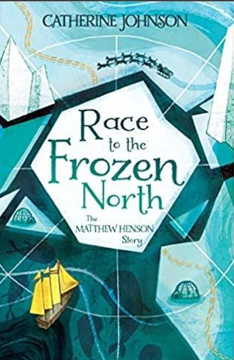
Subjects | Reading | In Reading, we will be exploring the book Race to the Frozen North and will be developing their reading skills through discussions, activities and a deeper understanding of the story and its themes.
Subjects | Maths | This term we will be introducing fractions, including how to add and subtract both mixed and improper fractions.
Subjects | Science | We will be investigating the properties of materials as well as investigating reversible and irreversible changes.
Subjects | Geography | We will be learning about the Arctic and Antarctic, exploring the similarities and differences as well as developing an understanding of why climate differs depending on location.
Subjects | Art | We will be studying the art of Hanson Akatti and will be creating collage in his style which can then be enhanced through the use of digital media.
Subjects | Music | In music, we will sing in unison and parts, focusing on pitch, phrasing, and style. We will build confidence and perform for an audience.
Subjects | Religious Studies | We will be looking at several religions this term and learn about and compare different places of worship and their importance in a community.
Subjects | Physical Education | This term, indoor PE will focus on dodgeball, where children will develop agility, coordination, and teamwork. Outdoor PE will be football, helping pupils improve passing, dribbling, shooting, and strategic play skills.
Subjects | Personal Development | This term, we will learn how teamwork and collaboration help people achieve shared goals, solve problems, and build positive relationships through cooperation, communication, and respect in school and beyond.
Subjects | Modern Foreign Language | In MFL, we will use Language Nut to learn Spanish, focusing on useful phrases and questions for everyday situations. They will practise speaking, listening and reading through interactive activities, building confidence, accuracy and enjoyment in using a new language.
Subjects | Computing | This term in computing we will be investigating spreadsheets and their functions.

