Year 2: Autumn 2 | Key Dates
What makes London and the United Kingdom Unique?  In Autumn 2, children will be exploring where Abbey Wood is in relation to London. Children will learn about the human and physical features of London including the River Thames and different landmarks. They will also visit the landmark Tower of London. | First day of term: 03.11.25  Parent Reading Morning – Every Thursday Morning  Flu immunisations – 05.11.25  Trip to Tower of London – 11.11.25  Odd Socks Day – 12.13.25  Christmas Jumper & Dinner Day – 11.12.25  WBP Winter Wonderland – 11.12.25  Autumn Term Reports – 15.12.25  EYFS/KS1 Nativity Performance to Parents – 17.12.25  KS2 Christmas Songs – 18.12.25  Last Day of Autumn Term – 19.12.25

Subjects | Writing | In Writing, we will be composing a setting description based on one of the London landmarks. We will also be researching famous places in London and creating fact files. | Core Text  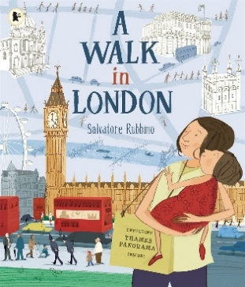
Subjects | Early Reading & Phonics | In Early Reading and Phonics, children will practise reading Charlotte’s Web using a range of strategies such as predicting, summarising and drawing inferences. They will also practise phonics sounds matched to their level.
Subjects | Maths | In Maths, we will be looking at numbers within 100, adding and subtracting these numbers and putting them into word problems.
Subjects | Science | In Science, we will be learning about everyday materials. We will identify, classify and describe them while performing investigations to test material suitability.
Subjects | Geography | In Geography, we will be identifying where Abbey Wood is in relation to London. We will also be exploring the different human and physical features including the River Thames and different London landmarks.
Subjects | DT | In DT students will learn about the history of Pearly Kings and Queens' attire and the materials used in their designs. They will also practice stitching techniques and create their own Pearly King or Queen-themed T-shirts with buttons.
Subjects | Music | In Music, we will be rehearsing the songs for our class Nativity, Little Angel Gets Her Wings.
Subjects | Religious Studies | In RE, our focus question is - We are going to learn about Christianity and how this links to our nativity performance.
Subjects | Physical Education | In PE, children will explore safe and creative movement in space, using timing, levels, and different pathways to travel. They will work in pairs to develop and perform movement patterns, using a poem or picture as inspiration, and reflect on their posture and cooperation skills.
Subjects | Personal Development | In Personal Development, children will learn to recognise different types of bullying, including online behaviour and how to respond if they or others experience hurtful actions.
Subjects | Computing | In Computing, students will learn to use the 'Pages' document app to create and format documents. They will explore features like text formatting, adding images, and organising layouts.

