Year 1: Summer 2 | Key Dates
Big Question: Who are the heroes of the Crimean War?  The children will be introduced to our term’s theme through an interactive workshop about Florence Nightingale and Mary Seacole, run by the Army Museum. This engaging session will provide an in-depth look at their lives, contributions to nursing, and impact during significant historical events, helping to bring history to life in an exciting and memorable way.  In Arts Fortnight the children will be exploring the artists, music and popular dances of the 1970s. | Monday 2nd June: Florence and Mary workshop run by the Army Museum  Wednesday 4th June: Sports Day  Tuesday 10th June: Science Day  Friday 4th July: WBP Festival  Wednesday 9th July - Significant Women workshop run by the National Archives  Last Day of Summer term: Tuesday 22nd July


Subjects | Writing | In Writing, we will be reading The Extraordinary Life of Mary Seacole to learn about her inspiring story. Using this, we will create a biography and a fact file to share key details about her life and achievements. | 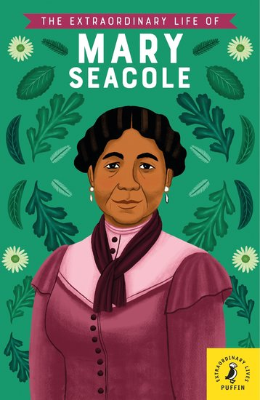  Core Text
 | Early Reading & Phonics | In Early Reading, we will be focusing on decoding, prosody, and comprehension. In Phonics, we will continue to work on Phase 5 phonemes, including new graphemes and alternative pronunciations.
 | Maths | In Maths, we will be learning about money, including recognising coins and notes and solving simple problems. We will also focus on telling the time to build confidence with clocks and schedules.
 | Science | In Science, we will be learning about seasonal changes, exploring how weather, daylight, and nature vary throughout the year. This will help us understand the patterns and effects of different seasons.
 | History | In History, we will be learning about the lives of Florence Nightingale and Mary Seacole. We will explore their contributions to nursing and the impact they made during their time.
 | Art | In Art, we will be learning about the artist Georgia O’Keeffe and her unique style. We will practise drawing and explore watercolour painting to create artwork inspired by her techniques.
 | Music | In Music, we will be learning about improvision using our voices and musical instruments. We will also be learning about composition and performing our finished pieces to an audience.
 | Religious Studies | In RE, we will be exploring the question – what does it mean to belong to a faith community? We will explore that some people belong to a religious community and what this might look like.
 | Physical Education | In gymnastics, we will be learning to create different shapes and movements with our bodies, building strength and flexibility. We will also practise key skills, such as running, jumping, and balancing, to prepare for the exciting events on Sports Day.
 | Personal Development | In Personal Development, we will be learning about emotions and exploring different feelings. We will discuss how to recognise and manage these emotions in ourselves and others.
 | Computing | In Computing, we will be learning about simple networks and how information is connected and shared. Additionally, we will explore data representation, including creating and interpreting bar charts.

