Year 5 Spring 1 | Key Dates
Year 5 Spring 1 Big Question: How has space exploration changed our world?  Throughout this topic, the children will learn about space and the history of space exploration. Children will explore our universe using NASA’S website. We will also be watching the film Hidden Figures throughout the first week. | First day of term: Monday 7th January  Last day of term: Friday 13th February


Subjects | Writing | This half term, we will be interviewing Dr Christine Mann Darden, one of the women at NASA who acted as a computer. We will use this information to later write a newspaper report about the moon landing. | Core Text  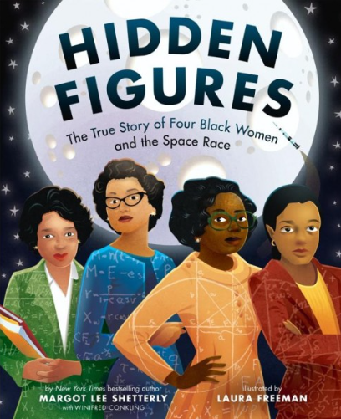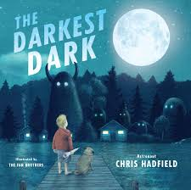
Subjects | Reading | This term, children will read Hidden Figures alongside a range of poetry, exploring themes of equality, perseverance and achievement while developing comprehension, inference and discussion skills.
Subjects | Maths | In Maths, we will be working on multiplying and dividing 4-digit numbers, as well as building on our learning with fractions to include decimals and percentages.
Subjects | Science | In Science, we will be exploring our Solar System and the movements of the planets. We will investigate the phases of the Moon, how shadows move throughout the day and what happens during an eclipse.
Subjects | Geography/ History | This half term, we will be learning about the history of the Space Race during the cold war, as well as the segregation that was in place in America during that time.
Subjects | Art/DT | This half term we will be focussing on Design and Technology, we will be making a CAMS toy based on the movement of celestial bodies.
Subjects | Music | In music, children will record, mix and add sound effects to their compositions, then perform and share spooky story tracks, developing confidence, creativity, collaboration and reflective listening skills.
Subjects | Religious Studies | In RE, we will be learning about the Pillars of Islam and the way these affect the way Muslims live their lives.
Subjects | Physical Education | Indoor PE will focus on Dance Through the Ages, exploring movement styles from different periods, while outdoor PE will develop agility, teamwork and fitness through the game Tag Rugby.
Subjects | Personal Development | This term we will be looking at what is meant by a growth mindset, as well as exploring the British Values of Individual Liberty and Rule of Law.
Subjects | Modern Foreign Language | In MFL, children will learn vocabulary linked to Around the House, naming rooms and areas and describing everyday household jobs through speaking, listening and simple sentence-building activities.
Subjects | Computing | This term we will be investigating the different uses of AI technology, the advantages and disadvantages of this technology and how to keep yourself safe online.

