Year 1: Spring 1 | Key Dates
Big Question: Has how we travel changed over time?  This term the children will be exploring different modes of transport whilst comparing different modes of transport from the past and present.  Hook  The children will be following a set of instructions to make their own instrument using recycled materials! | First day of term: Monday 6th January  Trip to the Nest: Friday 16th January  Traveller workshop: TBC  Last day of term: Friday 13th February  Yew Class Sharing Assembly: TBC


Subjects | Writing | In English, the children will be exploring the book Ossiri and the Bala Mengro. For the incidental outcome, the children will be writing a set of instructions on how to make an instrument out of recycled materials. For their final outcome, the children will be writing a persuasive speech from Ossiri’s grandfather to her dad, telling him why she should take the instrument to the next place they are going to. | Core Text  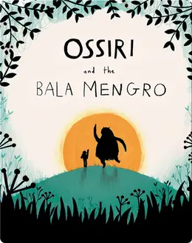
Subjects | Early Reading & Phonics | We will continue with our guided reading sessions and children will have daily phonics, focussing on phase 5.
Subjects | Maths | In Maths, we will be learning about place value within 20, building on our knowledge from the Autumn term. We will then go on to exploring addition and subtraction within 20 and how we can use a range of manipulatives to help us identify tens and ones.
Subjects | Science | This half term we will be recapping our knowledge learnt from our previous topics of Plants and Everyday Materials.
Subjects | History | In History, the children will be looking at different transport modes and comparing them from the past and present. We will explore various questions about this including our big question of ‘Has how we travel changed over time?
Subjects | Art/DT | In Design Technology, the children will learn about wheels and axles. The children will design and create their own wheeled cart.
Subjects | Music | Our module this half term is Music Inspired by the World Around Us. We will be listening to compositions such as Moonlight Sonata and The 4 Seasons.
Subjects | Religious Studies | In RE, we will be exploring the terms ‘sacred’ and ‘holy’. We will consider why places are considered as sacred and holy. We will have the opportunity to explore different symbols in both Christian and Jewish religions and understand their significance.
Subjects | Physical Education | In PE, the children will be undertaking a gymnastics unit where they will learn how to make wide, narrow and curled shapes using the floor and various gymnastics equipment. Children will also be learning how to manipulate different objects including bats and balls.
Subjects | Personal Development | In Personal Development, we will be learning about living in the wider world, being part of a community and what this means to us.
Subjects | Computing | In Computing, pupils will be learning about AI - finding out what it is and how it is used in daily life.

