Reception: Autumn 2 | Key Dates
Year Group: Reception Term: Spring 1  Who is afraid of the Big Bad Wolf?  This theme allows children to explore traditional tales. Our selected fictional stories will spark their imagination and curiosity, while also supporting their communication and language development. Children’s expressive art and design skills will be enhanced through narratives and role play, aligning with the trust’s focus on oracy. | Key Dates  - Monday 5th January – first day of term  - Friday 13th February – last day of term  - Every Thursday – parent reading morning 8:40-9:10am.


Areas of Learning | Literacy – Writing | We will explore Traditional Tales, reading stories such as The Little Red Hen. In Phonics, we have now moved to Phase Three, to focus on learning vowel digraphs and trigraphs. We will also practice reading longer words using ‘chunking,’ which helps break the words into manageable parts, making the blending process easier. | Key Texts  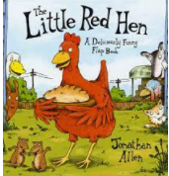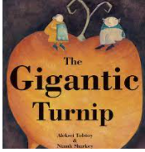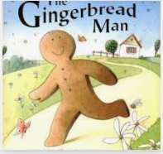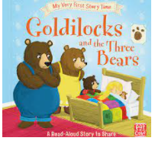
Areas of Learning | Literacy - Reading & Phonics | 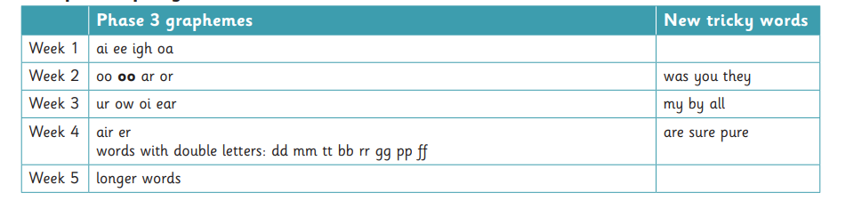
Areas of Learning | Maths | In Maths, we will explore the numbers 0–5 in even greater depth, consolidating our skills in subitising and representing one more or one less than a given number. We will also get to know the numbers 6, 7, and 8, while learning about doubling and combining groups.
Areas of Learning | Understanding the World | This term we’ll become keen observers of the natural world as it transitions from winter to spring, engaging in outdoor learning to explore habitats and wildlife. We’ll watch for birds, bugs, and insects, and draw them with pencil. We’ll also learn how to plant seeds in preparation for spring.
Areas of Learning | Expressive Art and Design | This term, we will explore a range of materials and equipment to create artwork and collages. We will paint with fruits and Numicon to create fabulous repeating patterns. Additionally, we will use our imagination to create new worlds and engage in role play. We will continue to sing songs and learn through rhymes.
Areas of Learning | Personal, Social, Emotional Development | We will learn to listen to opinions different from our own and how to respond respectfully, using appropriate language to support our social skills. We will also explore the importance of looking after our bodies, including healthy habits, food hygiene, and personal hygiene.
Areas of Learning | Physical Development | We will continue to practice our fine motor skills, including holding a pencil with a tripod grip. In our PE lessons, we will explore fundamental movement skills, such as throwing and catching a ball, jumping safely from a low height, and moving through space safely
Areas of Learning | Communication & Language | Our new topic offers a vocabulary-rich environment where we will use new language in games and storytelling, bringing books to life with our imagination and creative play skills. We will also develop confidence in speaking within group settings and begin using longer sentences to express ourselves.

