Reception: Autumn 1 | Key Dates
Big Question: What makes me special?  Topic Overview  In Autumn 1, the children will begin to learn about themselves, their families and others. This introductory topic will allow the children to explore how they are similar and different to one another, their likes and dislikes and the school rules and routines through a range of relevant texts. The children will initially be introduced to mark making and letter formation before writing CVC words and short captions. | Every Thursday – Parent Reading Morning  Friday 19th September – Jeans for Genes Day  Wednesday 8th & Thursday 9th October – Parents’ Evening  Friday 10th October – World Mental Health Day  Friday 17th October – Last day of term


Areas of Learning | Literacy – Writing | In literacy, we will use a range of key texts to introduce our topic, through the use of Talk4Writing. The children will use a story map and actions to retell stories confidently. The children will begin to write simple words and labels using early phonics. | Key Texts  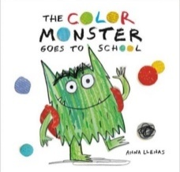  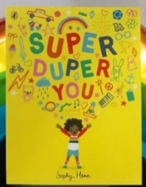  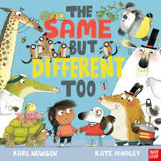  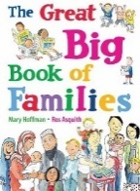  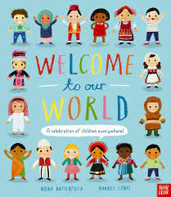
Areas of Learning | Literacy - Reading & Phonics | 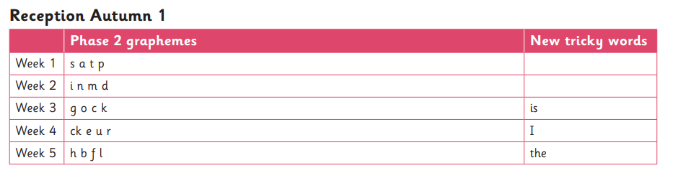
Areas of Learning | Maths | In maths, we will begin to explore pattern, shape and numbers up to 6. We will use a range of activities and resources to become familiar with early mathematical experiences and use daily Maths Meetings to learn the days of the week, months of the year, seasons, shape, pattern and early number.
Areas of Learning | Understanding the World | We will begin to explore the world around us through a range of key texts in relation to our topic. We will try different fruits from around the world, learn about different families, homes and traditions and explore how we are all unique. We will also learn about our new school environment by exploring each new area.
Areas of Learning | Expressive Art and Design | In art and design, we will learn to safely use and explore a variety of tools, techniques and materials and experiment with colour, materials and textures. We will begin to express ourselves through songs, rhymes, dance and role play activities.
Areas of Learning | Personal, Social, Emotional Development | We will begin to get to know our friends and teachers through lots of circle time activities and games. We will learn to talk about our feelings and play collaboratively with our peers to enable us to form great relationships.
Areas of Learning | Physical Development | In physical development we explore how our bodies can move in different ways through balance and coordination games in PE. We will also engage in a range of fine motor activities in order to help holding a pencil correctly.
Areas of Learning | Communication & Language | We will learn to communicate effectively with our peers and teachers. Through storytelling, class discussions, games and circle time activities, we will build confidence when speaking in a group and learn how to share our ideas with others and listen to our friends.

